**Middle Country Central School District**

**2019-2020**

**enVision 2.0 Parent Handbook**

**How can I Help My Child Online Using enVision 2.0?**

**How do I sign on?**

**Step 1**: Go to [www.mccsd.net](http://www.mccsd.net).

**Step 2**: Click on PowerSchool (symbol at the top of the website).



**Step 3**: Click on the icon labeled, “parent & student login”.

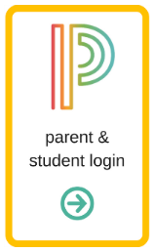

**Step 4**: Type in your USERNAME and PASSWORD.

**Step 5**: Click on “Pearson Courses” on the left side of the page.

**Step 6**: Click on “Pearson Realize”.



**My child forgot their homework. How can I find the practice page online?**

Find the textbook on the Pearson Realize page. Then, find the Topic and Lesson for the homework. The practice page can be found in the “Student’s Edition eText.”

**Where can I find games and additional practice for my child?**

Find the textbook on the Pearson Realize page. Then, click on the appropriate topic.

* The “Student’s Edition eText” is a digital copy of their print textbook.
* The “Interactive Student Edition” allows students to access digital manipulatives related to the lesson and write in the book online.
* The “Visual Learning” is a video that explains the lesson. Some students may watch this in class.
* The “Another Look” video reteaches the topic in a different way for students who may still be struggling.
* Any additional games, practice problems, and other resources will be in the “Assess and Differentiate” section.